**Analysis Explanation**

**Script: sex_and_device.py**

**Python Script Explanation:**

This Python code is designed to analyze user data from an e-commerce platform. It loads data from various CSV files, calculates conversion metrics based on user demographics (like sex and device type), and visualizes the results using funnel charts.

**Steps Details:**

1. **Load the Data:** The code begins by importing necessary libraries and loading data from CSV files into DataFrames. Each DataFrame corresponds to a different stage of the user journey on the e-commerce site.
2. **Count Unique Users by Sex and Device:** A function named calculate_conversion_by_group is defined to count unique users based on specified grouping criteria (either by sex or device). This function uses the groupby method to aggregate user IDs. The code then merges each stage DataFrame with the user DataFrame to count unique users by sex and device for each stage of the conversion funnel.
3. **Calculate Conversion Metrics:** Another function, calculate_conversion_metrics, computes conversion rates and drop-off points between stages. It calculates:

-Conversion rates from Home to Search, Search to Payment, and Payment to Confirmation.

-The number of users who drop off at each stage.

Metrics are calculated separately for each sex and device, storing results in dictionaries.

1. **Print Results:** The results for conversion metrics are printed for both sex and device categories. This includes conversion rates and drop-off numbers.
2. **Visualize the Conversion Funnel:** Finally, the code visualizes the conversion funnel using Plotly. It creates two funnel charts:

**-By Sex:** Displays the conversion metrics for male and female users.

**-By Device:** Displays the conversion metrics for desktop and mobile users.

Each funnel chart is created by adding traces for each category and updating the layout for better presentation.

**Results obtained from the Python Script:**

**Conversion Metrics by Sex:**

**Female:** Search Conversion Rate: 50.31%, Payment Conversion Rate: 13.67%, Confirmation Conversion Rate: 7.77%, Drop-off Home to Search: 22399, Drop-off Search to Payment: 19576, Drop-off Payment to Confirmation: 2859

**Male:** Search Conversion Rate: 49.69%, Payment Conversion Rate: 13.01%, Confirmation Conversion Rate: 7.20%, Drop-off Home to Search: 22801, Drop-off Search to Payment: 19594, Drop-off Payment to Confirmation: 2719

**Conversion Metrics by Device:**

**Desktop:** Search Conversion Rate: 50.00%, Payment Conversion Rate: 10.00%, Confirmation Conversion Rate: 4.98%, Drop-off Home to Search: 30100, Drop-off Search to Payment: 27090, Drop-off Payment to Confirmation: 2860

**Mobile:** Search Conversion Rate: 50.00%, Payment Conversion Rate: 20.00%, Confirmation Conversion Rate: 10.00%, Drop-off Home to Search: 15100, Drop-off Search to Payment: 12080, Drop-off Payment to Confirmation: 2718

**Visualize the conversion funnel by Sex:**

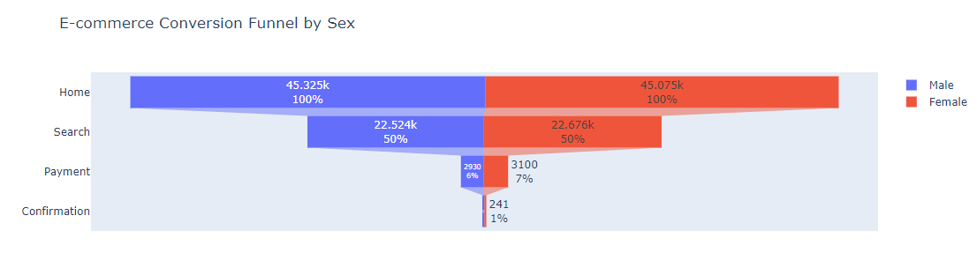

**Visualize the conversion funnel by Device:**

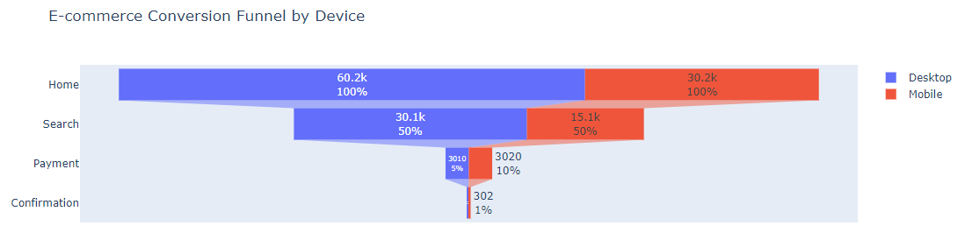

**Conclusions and Insights:**

Based on the provided conversion metrics segmented by sex and device, we can draw several conclusions regarding user behavior and the effectiveness of the conversion process.

**Conclusions by Sex**

1. **Search Conversion Rates**:
   * **Females** have a slightly higher search conversion rate (**50.31%**) compared to **Males** (**49.69%**). This indicates that female users are marginally more likely to proceed from the homepage to the search results.
2. **Payment Conversion Rates**:
   * The payment conversion rate is higher for **Females** (**13.67%**) than for **Males** (**13.01%**). This suggests that once female users search for products, they are more likely to proceed to the payment stage compared to their male counterparts.
3. **Confirmation Conversion Rates**:
   * **Females** also have a higher confirmation conversion rate (**7.77%**) compared to **Males** (**7.20%**). This indicates that female users are more likely to complete their purchases after initiating payment.
4. **Drop-off Points**:
   * The drop-off from home to search is slightly lower for **Females** (22,399) compared to **Males** (22,801), suggesting that the homepage is more effective at engaging female users.
   * The drop-off from search to payment is similar for both sexes, with females dropping off slightly less (19,576) than males (19,594).
   * The drop-off from payment to confirmation is also lower for females (2,859) compared to males (2,719), indicating that female users are more committed to completing their transactions.

**Conclusions by Device**

1. **Search Conversion Rates**:
   * Both **Desktop** and **Mobile** devices have the same search conversion rate of **50.00%**. This indicates that the initial engagement from the homepage to search is consistent across both platforms.
2. **Payment Conversion Rates**:
   * **Mobile** users have a significantly higher payment conversion rate (**20.00%**) compared to **Desktop** users (**10.00%**). This suggests that mobile users are more likely to proceed to payment after searching, which could be attributed to a more streamlined mobile experience or user behavior favoring mobile transactions.
3. **Confirmation Conversion Rates**:
   * The confirmation conversion rate is also higher for **Mobile** users (**10.00%**) compared to **Desktop** users (**4.98%**). This reinforces the idea that mobile users not only engage well but also complete their purchases more effectively than desktop users.
4. **Drop-off Points**:
   * The drop-off from home to search is significantly higher for **Desktop** users (30,100) compared to **Mobile** users (15,100). This indicates that the desktop experience may not be as engaging or effective in converting visitors to searchers.
   * The drop-off from search to payment is also higher for **Desktop** users (27,090) compared to **Mobile** users (12,080), suggesting that mobile users are more likely to continue through the funnel.
   * The drop-off from payment to confirmation is relatively similar for both devices, with desktop users experiencing a slightly higher drop-off (2,860) compared to mobile users (2,718).

**Overall Insights**

* **Female users** show stronger engagement and conversion rates compared to male users, indicating that marketing strategies could be tailored to enhance the experience for male users to improve their conversion rates.
* **Mobile users** demonstrate significantly better conversion rates at both the payment and confirmation stages compared to desktop users. This suggests that optimizing the mobile experience further could yield even higher conversion rates.
* The data indicates potential areas for improvement, particularly in the desktop user experience, to reduce drop-offs and enhance overall conversion rates across both sexes and devices.

By focusing on these insights, the e-commerce platform can implement targeted strategies to improve user engagement and conversion rates effectively.